# Class Work - COMP392-001 - Week 1

Muhammad Sabeeh

**Class Work - COMP392-001 - Week 1** **1**

**Create a simple PPM image:** **3**

**View it in GIMP:** **3**

**Small Challenge 1: Add a row with your own colours:** **3**

**Create a console C++ app in VS2022:** **4**

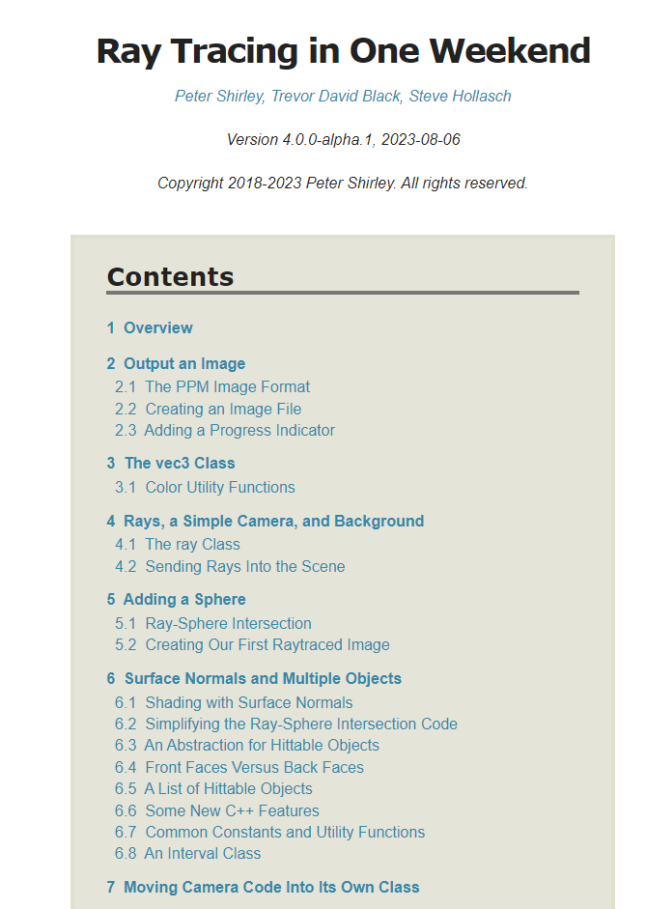

# Create a simple PPM image:

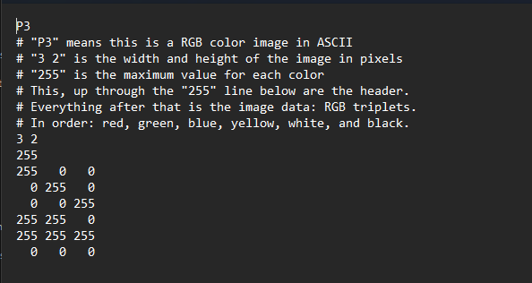

# View it in GIMP:

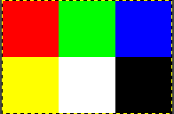

# Small Challenge 1: Add a row with your own colours:

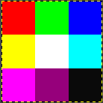

# Create a console C++ app in VS2022:

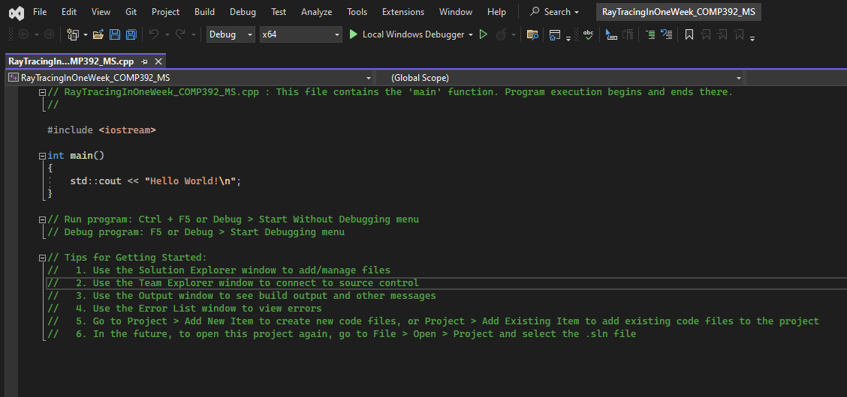

# Code:

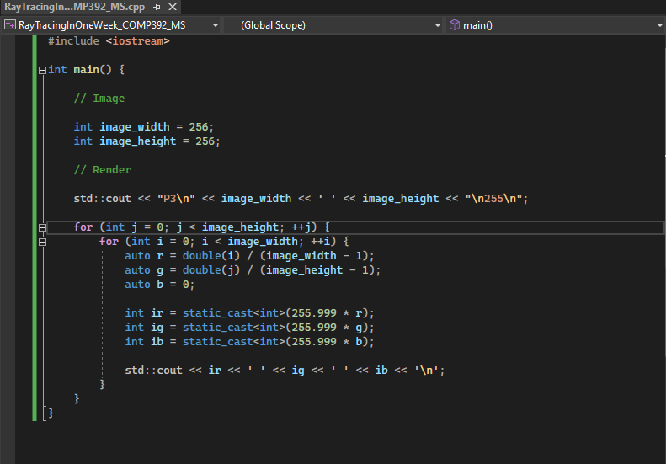

# Create the first image:

